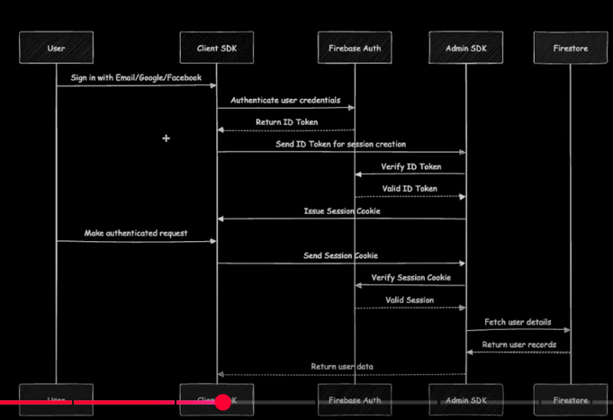

**NOTE**: Authentication on server side is recommended, though seems to be much more complicated but still